Dear reader,
Before diving deep into the untold impact of different contractual agreements on the final oil price, we must get acquainted with the stage where all these contracts exist.
We should understand the bigger picture of what upstream oil is, along with key concepts such as exploration and production, and their main players.
Once we have this broader understanding, we will be able to move forward and examine the relationship with oil prices.
So, What is upstream oil?
Upstream is the first phase of the supply chain that commodities like oil or gas go through. It is this stage where National Oil Companies (NOCs) or International Oil Companies (IOCs) discover new fields of hydrocarbons and proceed with the exploration, development, and extraction of crude oil from the soil.
It is in this stage where the rights over the oil and the subsoil resources are defined, although in most countries the ownership of the resources remains with the state.
Companies whether national or private, or even the state itself through its companies operate under legal frameworks such as concessions, production sharing agreements, or licenses (we are going to talk about that further on in this article), which allow them to handle the extraction.
Once the crude oil is extracted, it has to be transported to refineries and then treated for final consumption and different types of products such as fuels, petrochemicals, and other derivatives.
To get the full picture of what is being done in this stage, lets think as a triangle(like the image below
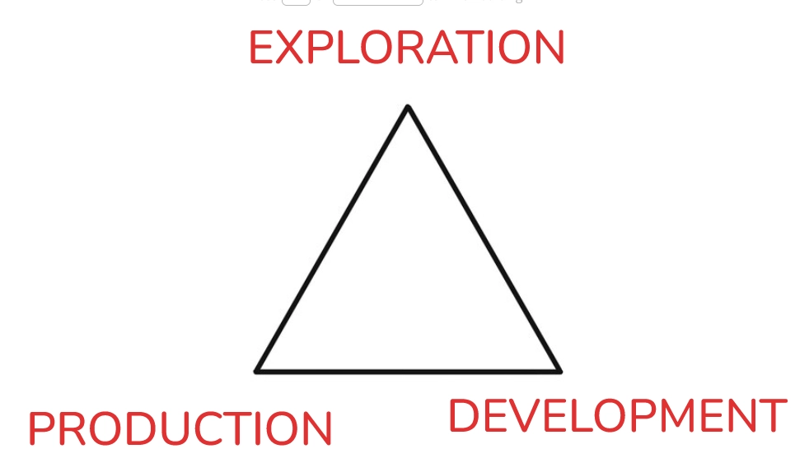
However, before any of these phases even begin, the legal and contractual framework has already been defined.
This is where agreements such as concessions, Production Sharing Agreements (PSAs), and licenses come into play.
These contracts determine who has the right to explore, develop, and produce the resource, how costs and revenues are shared, and ultimately how the value created in this triangle is distributed between the state and the operating companies.
CONCESSION AGREEMENTS
All this said, shall we begin with the first type of contract, the CONCESSION AGREEMENTS
A concession agreement involve the transfer of exclusive rights to explore and produce (typically held by the state, possibly represented by a public entity) to one or more where can be a ICO (international oil company) or NOC ( National Oil Company)
These companies undertake exploration and production at their own risk.
However the gain the ownership of the hydrocarbons produced and the freedom to manage them, provided they comply with the contractual obligations and fiscal requirements set by the state.
As far as we talk about oil, it seen by states as a strategic asset that's why it is often mandated that a portion of production is allocated to satisfy the domestic market needs of the producing country.
As we can see in the image below, depicts the spatial distribution of oil and gas concession blocks in Libya, where the government have autorizhed new concessions. Located in offshore areas in the Mediterranean Sea, specifically the Sabratha and Sirte offshore sectors, alongside various licensing units (O13, O14, S1) categorized for exploration and production activities.
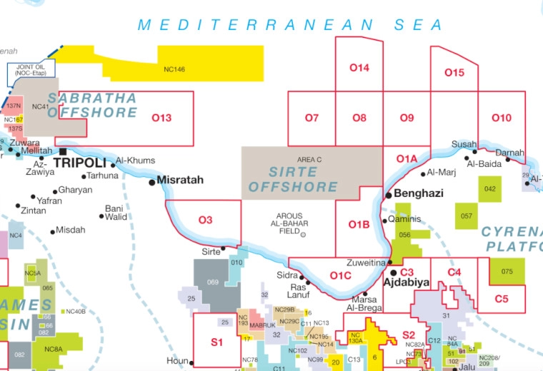
From a pricing perspective, this type of contractual framework tends to encourage higher levels of production, as companies are directly exposed to market prices and benefit from increasing output.
As a result, concession systems can contribute to higher global supply, which, all else equal, can exert downward pressure on oil prices.
At the same time, since the state has less direct control over production levels compared to other contractual models, its ability to influence prices through supply management is more limited.
However, this dynamic changes when the operator is a National Oil Company (NOC) and isn’t a ICO such as ( BP, Shell, Exxon, Chevron…)
Although NOCs may operate under concession agreements, they are often influenced by government objectives that go beyond profit maximization.
This means that production decisions can be aligned with national policies, revenue stability goals, or international commitments, rather than purely market signals.
Some countries under a high licenses and concessions contracts are: United Kingdom, USA, Canada, Norway…
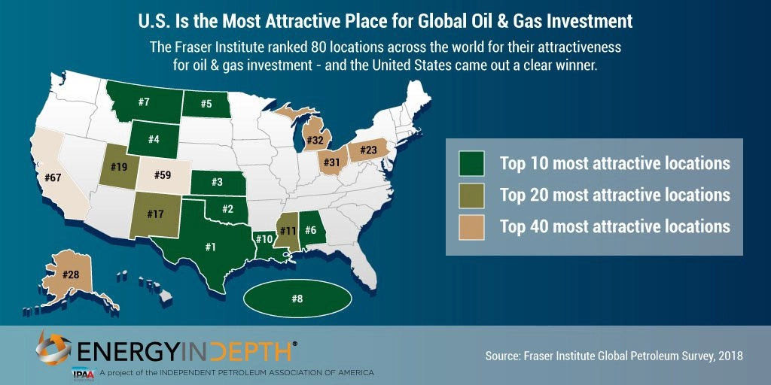
Production Sharing Agreement
We talked about the most capital-intensive form of contract. Now it’s time to reduce the liberties of E&P, which is why we introduce the so-called Production Sharing Agreement (PSA).
PSA’s were developed in Indonesia in the early 1960s. Since then, PSA’s have become a reference model for various oil-producing countries, such as Angola (watch the image below countries in yellow)
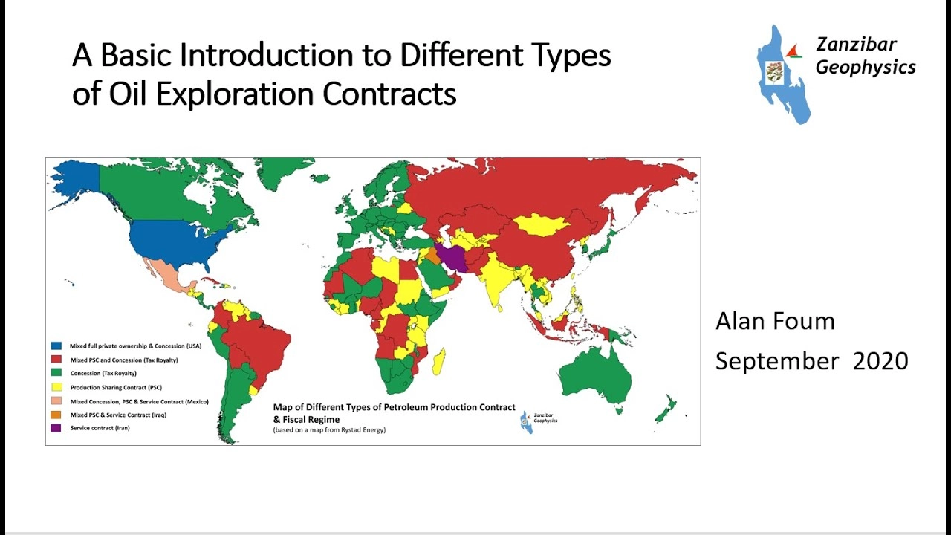
It was initially adopted as a response to the imbalance between Middle Eastern producing countries and oil companies, which was evident in the early Concession Contracts.
The PSA fundamentally changed the ownership structure of extracted hydrocarbons, which had previously belonged to the oil companies, by transferring the ownership to the state.
Consequently, instead of receiving royalties as compensation for granting oil companies the exclusive right to exploit these resources, the state assumes ownership of the extracted hydrocarbons.
A portion of these resources is then allocated to the oil company as payment for its operational activities and the risks associated with exploration and production.
However, in this form of contract the risk is for the E&P company, if hydrocarbons are not discovered or if the reserves are not commercially viable, the contract terminates without the oil company having any entitlement to recover its costs.
Compensation for the oil company occurs only if operations are successful, allowing it to recover the costs and investments incurred during the exploration and development phases through the receipt of a fixed percentage of the production called "cost oil”.
The remaining portion of the production, known as "profit oil," is shared between the producing country and the oil company according to the terms established in the contract.
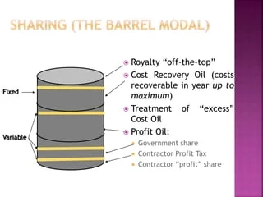
PSAs have their own distinct impact on oil prices.
When the state becomes more directly involved in the exploration and production (E&P) stage, companies are exposed less directly to market prices.
Under a PSA, companies first recover their cost oil and then share the profit oil with the state. As prices increase, the state often captures a larger share of the revenues. As a result, companies are less sensitive to price increases and do not aggressively ramp up production in response to higher prices.
In addition, political factors can directly influence production levels, thereby affecting oil prices.
However, if PSA terms are too strict, they may discourage foreign investment, leading to lower supply and, ultimately, higher prices.
In summary, under PSAs, oil prices are more likely to remain higher compared to a system based purely on concession contracts.
Risk Service Agreemets (RSA)
After seeing how concession agreements give companies maximum freedom and Production Sharing Agreements (PSAs) introduce greater state control, we arrive at an even more restrictive model: Risk Service Agreements (RSAs).
Unlike PSAs, where the company receives its share in barrels of crude oil, under RSAs the company acts as a contractor. The state retains full ownership of the oil at all times, and the company is paid a fee per barrel produced or for its operations by the IOC or NOC.
In other words, the company does not participate in production as a partner, but instead provides a technical and financial service.
Under Risk Service Agreements, crude oil prices are less driven by market incentives and more by state decisions.
This reduces supply flexibility and can contribute to tighter markets, making prices more rigid and often higher compared to more liberal contractual systems.

